Ventsense Client User's Guide

Getting Started 1

Launching Ventsense 1

Command-line Arguments 2

Configuration File 2

Serial Port 2

CSV File 2

I just want to see live sensor data... 3

I want to see relative pressure data... 4

I want all 3 sensors on one plot... 5

I want to customize the axes... 6

Fixed Y Axis 6

Autoscaled Y Axis 7

I want to see pressure data in my unit of choice... 8

I don’t want to see the plot... 9

I want to see data printed out on the console... 9

# Getting Started

IMPORTANT: The first time you launch ventsense, you must provide a serial port! See details lower down in this section.

## Launching Ventsense

Ventsense must be launched from a command prompt (aka terminal, in Linux or macOS lingo).

If you are using Windows or Linux, you can use the pre-built executables in the ventsense_client/bin folder.

Windows:

ventsense.exe

Linux:

./ventsense

Alternatively, on any platform, you can execute the script directly, using python:

python ventsense.py

If you choose to go this route, you must first install Python v3.5 or greater, as well as the pySerial, numpy, and matplotlib packages.

## Command-line Arguments

Regardless of the method you choose, command-line arguments are specified after the launch command, like so:

ventsense.exe -p COM1 --combined=true

Note that, by convention, single-letter arguments are preceded by one dash (-) and followed by its value, separated by a space. Whole-word arguments are preceded by two dashes (--) and followed by its value, separated by an equals sign (=). All arguments require values. You can see a listing of all possible arguments, their expected values, and their descriptions by using the -h argument:

ventsense.exe -h

## Configuration File

Command-line options are “sticky,” meaning they are remembered on subsequent launches. So, if you specify the serial port on the first launch, you never have to include it again, so long as the port does not change. The same goes for all other commands. Keep this in mind if you want to, say, switch from a combined plot to individual plots. It is not enough to simply remove --combined=true from the command-line arguments. You have to specify --combined=false!

Your settings are saved in a “settings.ini” file in the same directory in which you launched the application. The arguments and values you supply on the command-line get saved here. It also contains default values for the arguments you haven’t used. You can change settings either by using command-line arguments or by editing the settings.ini file directly.

## Serial Port

The first time you execute ventsense, you must provide the name of a serial port attached to an Arduino Uno running the ventsense firmware:

ventsense.exe -p COM1

## CSV File

Ventsense saves all temperature and pressure sensor data from serial port to a Comma-Separated Value (.csv) file. A .csv file will be created when you launch this script and then another one will be created each time you reset the Arduino. The .csv files can be opened in a spreadsheet app, such as Excel or LibreCalc.

The .csv files are named as follows, based on the date and time at creation:

ventsense_log_<YYYY-MM-DD_hhmmss>.csv

# I just want to see live sensor data...

ventsense.exe

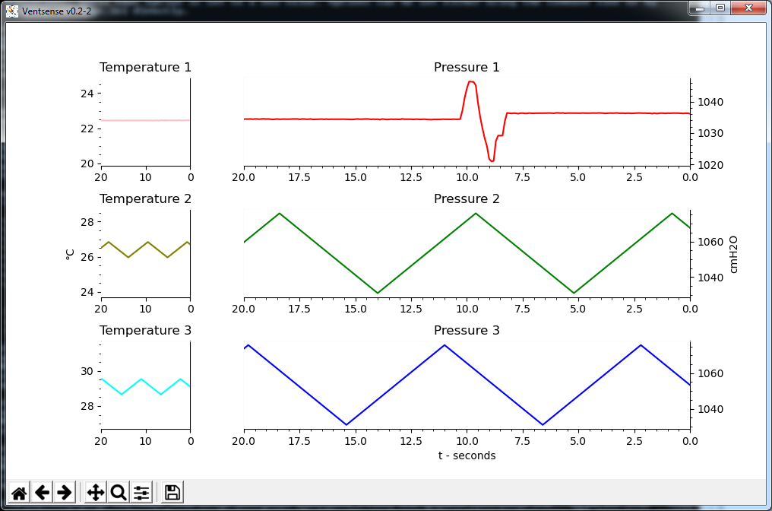

Executing ventsense without any command-line arguments generates a plot like the one above (assuming you’ve already set the serial port). By default, the units are in cmH2O, the sensor data values are absolute, the Y axes automatically resize based on the plotted data, and each sensor has its own plot.

# I want to see relative pressure data...

ventsense.exe --relative=true --atmospheric=1

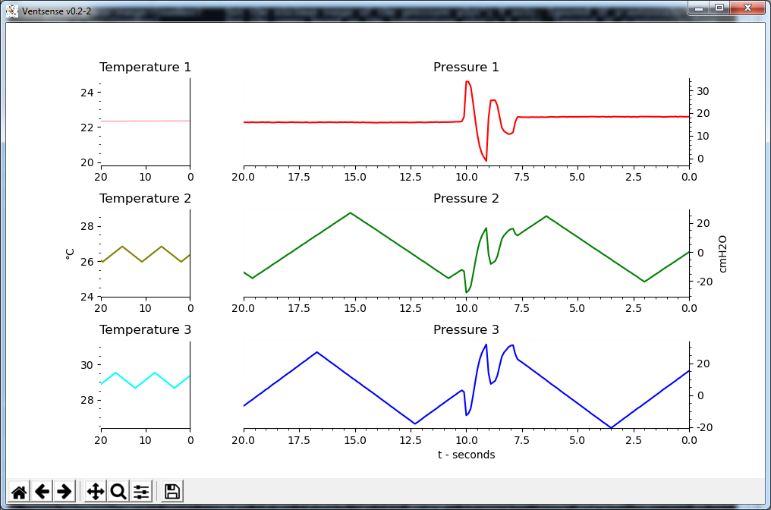

When plotting in relative mode, two of the sensors’ values are displayed relative to the third sensor, called the “atmospheric” sensor. You can specify the atmospheric sensor with the --atmospheric argument. The values of this argument must be 1, 2, or 3. If no atmospheric sensor is specified, then sensor 1 is used by default. The atmospheric sensor’s values are displayed relative to the typical atmospheric pressure at sea level, 1033 cmH2O.

# I want all 3 sensors on one plot...

ventsense.exe --combined=true

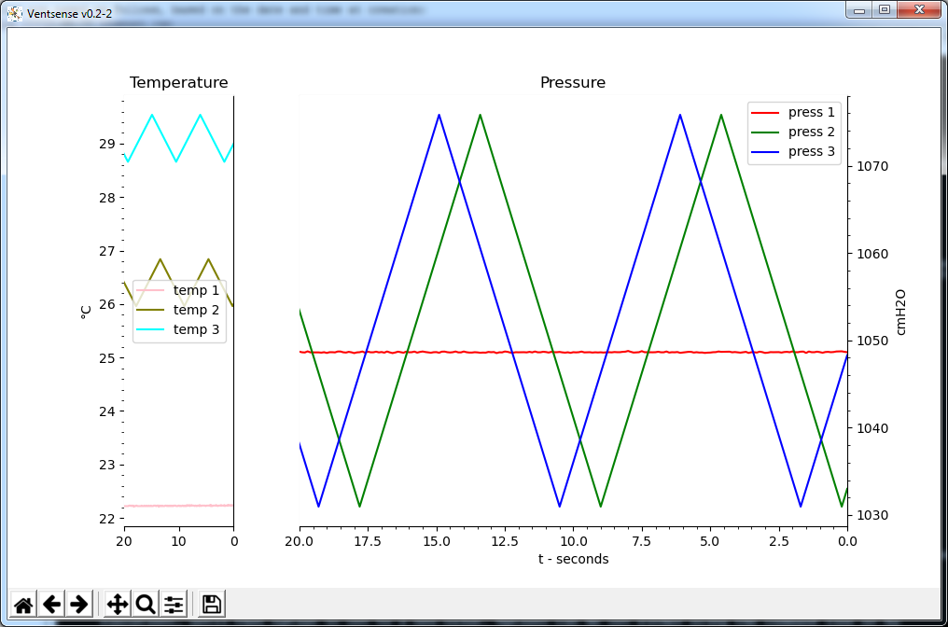

Using this option plots pressure values from all 3 sensors on one plot and all 3 temperature values on another.

# I want to customize the axes...

## Fixed Y Axis

ventsense.exe --y-autoscale=false --press-y-max=1050 --press-y-min=1030 --temp-y-max=28 --temp-y-min=22 --x-width=30

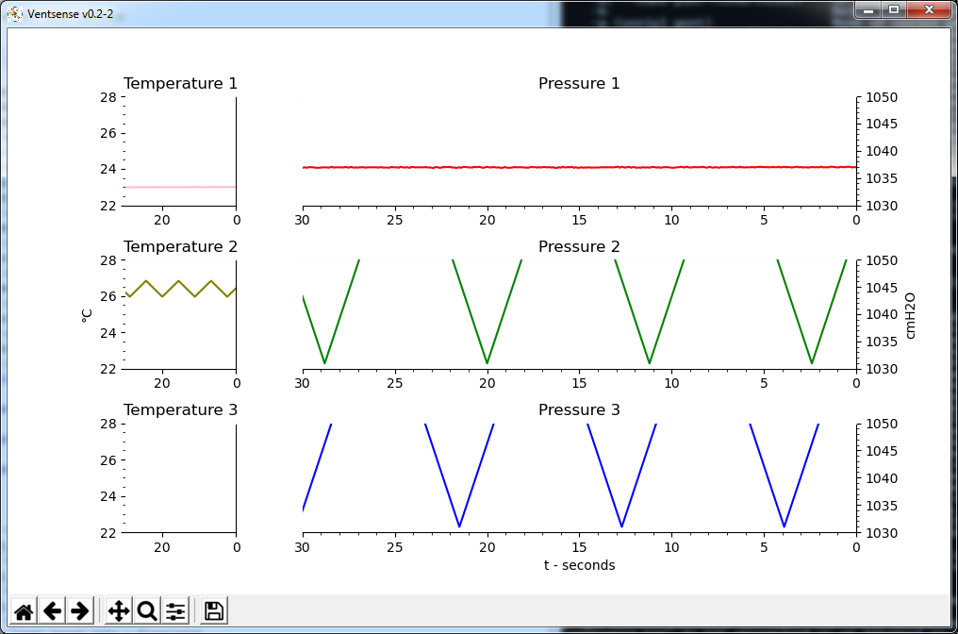

Setting --y-autoscale=false causes the Y axes to become fixed, per the specified upper and lower limits. Those limits are set by the following arguments:

* --press-y-max - Upper bound of the pressure plot’s Y axis
* --press-y-min - Lower bound of the pressure plot’s Y axis
* --temp-y-max - Upper bound of the temperature plot’s Y axis
* --temp-y-min - Lower bound of the temperature plot’s Y axis

The temperature Y axis bounds are shared among all temperature plots and the pressure Y axis bounds are shared among all Y axis plots. I.e., if --combined=false, all 3 pressure plots will show the same range of data.

The --press-y-min-range and --temp-y-min-range arguments are ignored when --y-autoscale=true.

The --x-width argument sets the amount of data history to plot, in seconds. This value is shared among all plots.

## Autoscaled Y Axis

ventsense.exe --y-autoscale=false --press-y-min-range=50 --temp-y-min-range=20

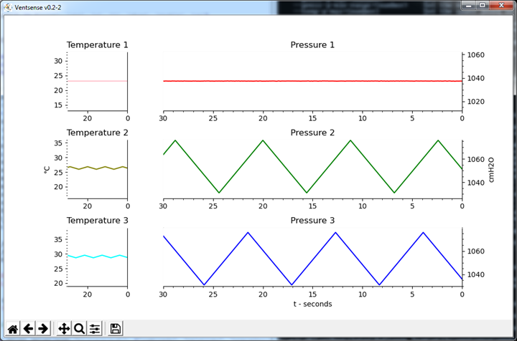

Setting --y-autoscale=true causes the Y axis to automatically scale, based on the plotted data. You can set the minimum Y axis range with the following arguments:

* --press-y-min-range - Minimum range of the pressure plot’s Y axis
* --temp-y-min-range - Minimum range of the temperature plot’s Y axis

The --press-y-max, --press-y-min, --temp-y-max, --temp-y-min, and --x-width arguments are ignored when --y-autoscale=true.

# I want to see pressure data in my unit of choice...

The plots use cmH2O by default. You can set it to use hPa instead, as follows:

ventsense.exe --use-cmh2o=false

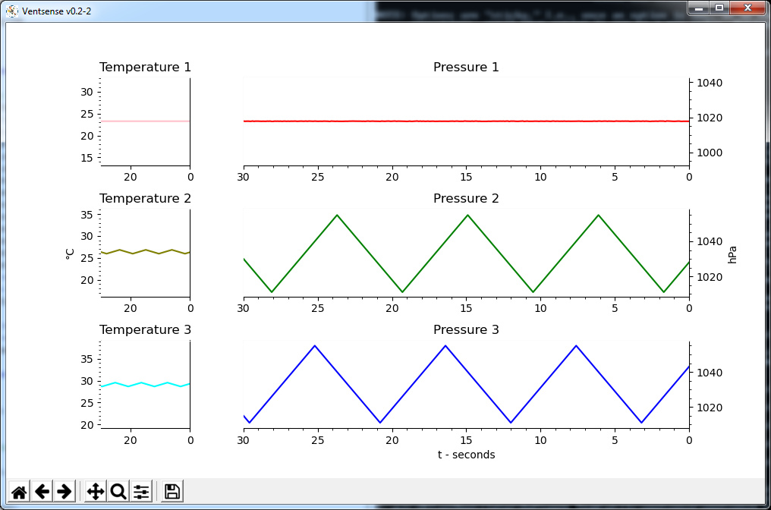

Setting --use-cmh2o=true changes it back to cmH2O.

# I don’t want to see the plot...

ventsense.exe --show-plot=false

This argument prevents ventsense from displaying a plot. The sensor data is still logged to a CSV file.

# I want to see data printed out on the console...

ventsense.exe --show-console=true

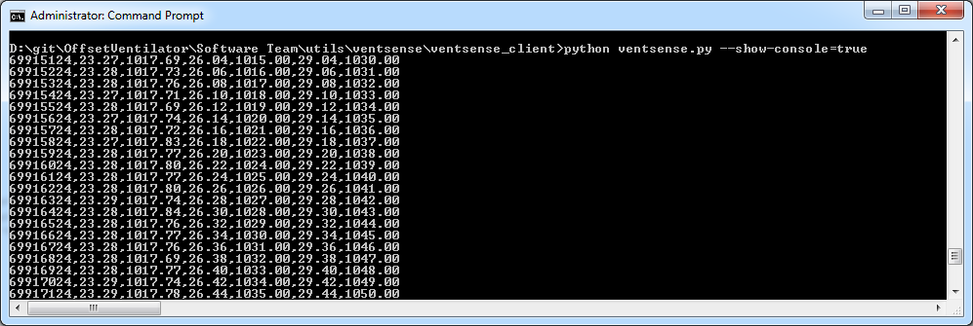

Ventsense prints all sensor data to the console as it comes in, when this argument is enabled. The sensor data is still logged to a CSV file.